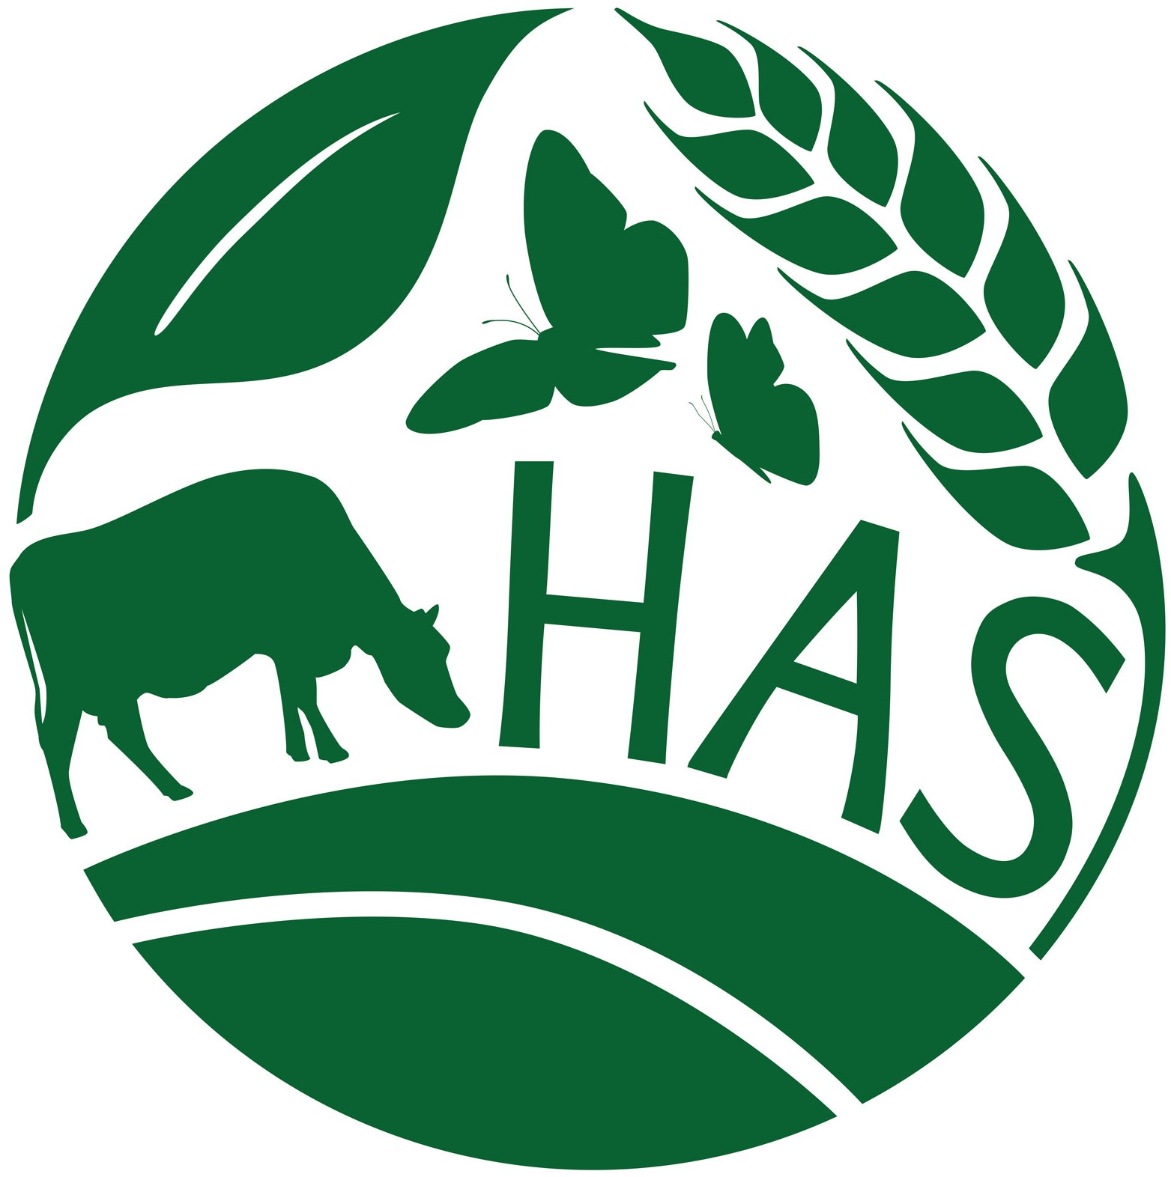

HEATHFIELD AGRICULTURAL SHOW

New Enterprise Zone Application Form

The Heathfield Agricultural Show has been a celebration of agriculture and business in our area for many years, the 2022 Show will be the Show’s 75th anniversary. The ongoing success of the Show was endorsed in 2019 when the Show was awarded the title of Best Agricultural Event in the South East at The Farmers' Ball in December.

Once again, we are offering new businesses the opportunity to take up a free stall at the Show on Saturday 28th May 2022. As well as having a trade stand on the day giving you a shop window to the thousands of visitors (19,000+ in 2019) who attend, you will also form part of our promotional campaign.

This is an amazing opportunity for someone just starting out.

There are terms for those wanting to apply for the stalls, please read these carefully:

1. You must be a new business and should not have been trading before June 2019.
2. You must live or run your business within the Heathfield area (within a 25 mile radius).
3. You must not have had a stall at the Show before as part of this business.
4. You must have public liability insurance for the day of the 28th May.
5. If your business is in alcohol products you will need to apply for a TENs license from Wealden District Council for the day. You will not be able to sell your products for consumption on the Showground but can offer tasters and sell for consumption at home.
6. If you are a food producer, unfortunately, you will be unable to sell your products on the day. You can, however, give away free samples and take orders.
7. You will need to be able to attend an interview in Brightling on Saturday 9th April.
8. Advertising your presence at the Heathfield Show on Social Media will be an important part of your campaign, the judges will be looking for your ideas so please make sure you include details of this in your application.

For a full list of all the terms and conditions for having a trade stand at the Heathfield Agricultural Show please visit www.heathfieldshow.org/tradestands.

Not sure if you live in the Heathfield area or have any questions before you apply? Please email Nicola, the Show Secretary on Secretary@heathfieldshow.org.

Please return your form by the 20th March to:

By post By email
2 Grants Cottage Secretary@heathfieldshow.org
Brightling, Robertsbridge
East Sussex TN32 5HZ
Are you a new business looking for exciting opportunities in 2022? If you are based in the Heathfield area and would like to showcase your business to our visitors please provide us with more information and you will be entered into the competition for a free stand.

1. Contact Details

Name:

Company:

Address:

Postcode:

Telephone:

Email:

1. When did you launch your business?

2. Please tell us about your business?

3. Tell us how it would benefit your business by being at the Heathfield Show?

4. Do you have a business website? Please include details here including social media links.

5. How would you make yourself stand out at the show?

6. You will be given a small stall at the show for free (2.5mx2.5m)
(Farmers’ Market style)
What will be your main activity on the day i.e. Sales, advertising, games

7. How will you promote the fact you are at the Heathfield Show to your

networks/ friends and family?

8. Tell us a bit more about why you think you should get a free stall
at the Heathfield Show?

Please confirm the following:

- I can show copies of my Public/Product Liability Cert.
- If I am a food business I can show copies of Food Hygiene Certificates
- If I am an alcohol business I can get a copy of TENs (Temporary Event Notice for Alcohol)
- If successful I will complete a Risk Assessment Form

Thank you for taking the time to apply for New Enterprise Zone at the Heathfield Show.

What's next?

- You will receive a confirmation email, thanking you for your application.
- Deadline for applicants is the 21st March 2022.
- If you have made it through to Round 2 you will be invited to an informal interview on Saturday 9th April in Brightling.
- The judging panel will make their decision on the successful applicants by the 11th April and all applicants will be contacted by email by the 13th April.
- If you are successful, we will send you the relevant paperwork which will need to be returned to us by 25th April to secure your stand.
- In the weeks leading up to the Show you will be sent clear instructions including details of timings, maps and main point of contact on the day.

Good luck!
If you have any questions please contact Nicola: Secretary@heathfieldshow.org

